ROYAL OAK INTERNATIONAL SCHOOL
SR. SEC. C.B.S.E. AFFILIATED (2019-20)
WHOLE YEAR SYLLABUS OF CLASS IV

SUBJECT-ENGLISH
MONTH | NO. OF WORKING DAYS | CONTENT | ACTIVITY | VOCABULARY | WORKSHEET
April | 18 | MCB-L1- The empty pot  Poem: The boy who never told lie  Dictation: L -1  Literature- Henri- The Red Cross Hero-I  Grammar- Articles, Sentences, Nouns  Writing – Notice | Introduction and explanation of chapter, Q/Ans., back exercise  Related to Poem : RTC, central idea,  Story-Central Idea of the story Grammar-Clear concept of noun and its kinds | Write two sentences on the value of truth  Make a tree of noun and depict its kinds as the branches of the tree. Complete a word grid | Grammar :Article, Sentence, Noun
May | 8 | MCB-L- 2 – Home Sweet Home  Poem- Grandparents are the best  Dictation words  Literature- Henri- The Red Cross Hero 2  Grammar- Antonyms  Writing- Diary Entry | Proper explanation of lesson, Q/Ans., back exercise  Value based question related to story  Literature- Back Exercise | Complete a word grid | Grammar - Antonyms
July | 24 | MCB-L- 3- Eureka Eureka  Poem – Newton’s Gravity  Literature-The Cruel King of the Jungle-I  Grammar- Simple Present Tense, Simple Past Tense  Writing- Paragraph, Advertisement | Q/Ans., fill ups, back exercises, Who said this  Poem-RTC with Central Idea.  Story- Story reading  Literature- Back exercises | Write who is the best men in the story & how he help the poor. | Grammar – Article, Present tense, Simple Past Tense  Writing – Paragraph, Advertisement
Written Evaluation Syllabus: PAI(July) M.M.:- (40)
MCB- Unit 1- The Empty Pot
Poem- The boy who never told lie
Unit 2- Home Sweet Home
Poem- Grandparents are the best
Literature- Henri- Ch1-The Red Cross Hero-I
Ch2- Henri – The Red Cross Hero-II
Grammar- Articles, Sentences , Nouns, Antonyms
Writing- Notice Writing, Diary entry
Aug. | 25 | MCB-L-4: Missile Man  Poem – Try Try Again  Literature- The Cruel King of the Jungle-2  Grammar- Present Continuous tense  Writing - Bio Sketch | Answering question back exercises  Story- Story Reading  Literature- Back Exercises  Grammar- Proper explanation of Present Tense  Writing- Bio Sketch of two great personalities | Write two positive and negative points of the king. | Grammar –  Present Continuous tense  Bio Sketch
Sept. | 4 | MCB-L- 5- Fantastic animals  Literature- Stop!Stop! Danger Ahead-I  Grammar- Verb | Write a paragraph on your favorite animal.  Literature- Back Exercises | Describe Gungadin in your own words showing how he proved t be a faithful worker.
Written Evaluation Syllabus: Half-Yearly Exam(September) MM:-(60)
MCB- Unit 3- Eureka Eureka
Poem- Newton’s gravity
Unit 4- Missile man
Poem- Try Try Again
Unit 5- Fantastic animals
Literature- Ch-4- The Cruel king of the jungle
Ch5- The Cruel King of the Jungle-2
Ch7- Stop!Stop! Danger Ahead-I
Grammar- Simple Present tense and Simple Past tense , Present Continuous tense, Verb
Writing- Paragraph Writing, Advertisement, Bio Sketch + Grammar and writing part of P.A.-I
Oct. | 17 | MCB-L – 6- Tenali Raman and two thieves  Poem – Riddles  Literature- Stop! Stop! Danger Ahead – II  Grammar- Adjectives and Pronouns  Writing – Formal letter  Story writing | Back ex. and Que/Ans  Poem- RTC and meaning of phrases.  Story-Story reading  Grammar- Definition and kind of Adjectives and degrees of Comparsion.  Writing- How to start a letter/context and how to end. | Literature- Question/Answer
Nov. | 9 | MCB-L-7- Mangalyaan  Poem – Cresent moon  Literature- Guru Nanak-I  Grammar- Adverbs and Homophones  Writing – Informal Letter | Poem-RTC and central idea of poem  Literature- Back exercises |  | Grammer – Adverb , Homophones, Revise tense
Written Evaluation Syllabus: PA-II(November)M.M:-(40)
MCB-Unit 6- Tenali Raman and two thieves, Poem- Riddles
Unit 7- Mangalyaan, Poem- Cresent moon
Literature- Ch8-Stop! Stop! Danger Ahead – II
Ch10-Guru Nanak-I
Grammar- Adjectives, Pronouns, Adverbs and Homophones
Writing- Formal letter ,Story writing, Informal Letter
Dec. | 20 | MCB- L-8-Sindbad  Poem – A good play  Literature-Guru Nanak-II  Grammar- Present Perfect Tense  Writing – Message Writing | Que/Ans and explanation of chapter.  Story- Story reading  Literature- Back Exercises | Paste the picture Guru Nanak and write a brief account on the teachings of Guru Nanak | Grammar – Present Tense
Jan | 19 | MCB-L- 9- Midas and the golden touch  Poem – Peddlers Caravan  Literature- Uncle tom I and II  Grammar- Conjunctions  Writing- Unseen Passage | Description about the characters “ Greed has no end” . Give proper explanation  Poem- RTC and Explanation  Story- Story reading  Literature- Back exercises  Grammar- How to join sentences | Revision work  Speaking skill ; develop a story on “ Greed is a curse of your own. | Grammar : Conjunction
Feb | 6 | Revision
Written Evaluation Syllabus: Yearly Exam(February) M.M:-(60)
MCB- L-8-Sindbad
Poem – A good play
L- 9- Midas and the golden touch
Poem – Peddlers Caravan
Literature-Guru Nanak-II , Uncle tom I and II
Grammar- Present Perfect Tense,Conjunctions
Writing – Message Writing,Unseen Passage
+ Grammar work and writing part done from April to January

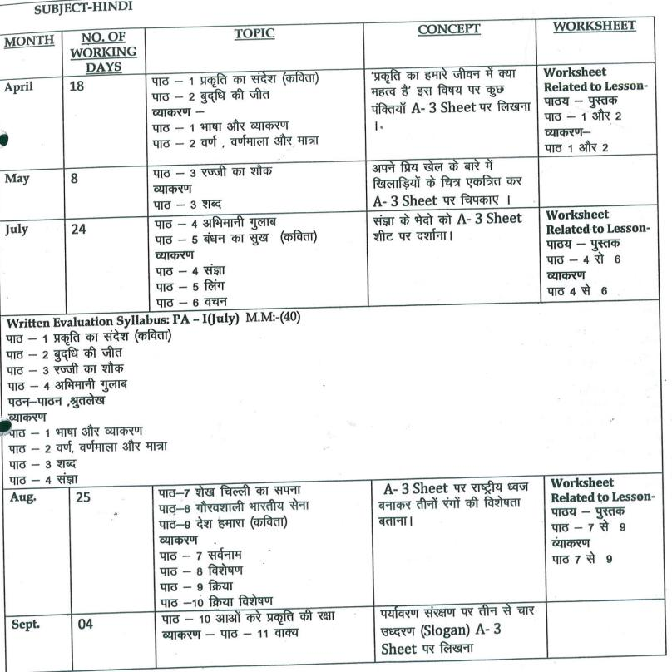
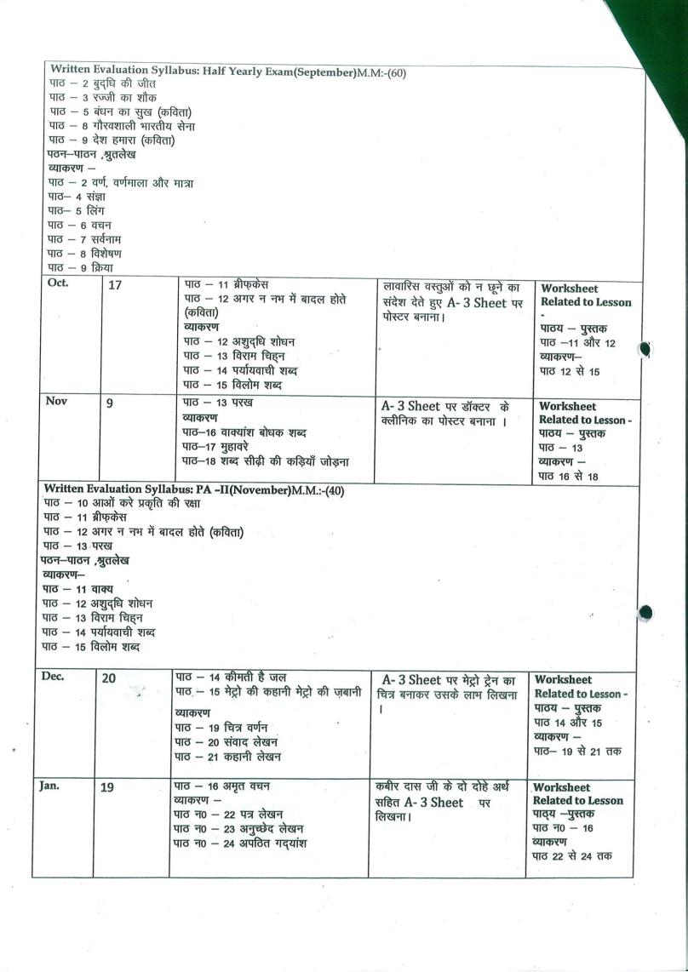
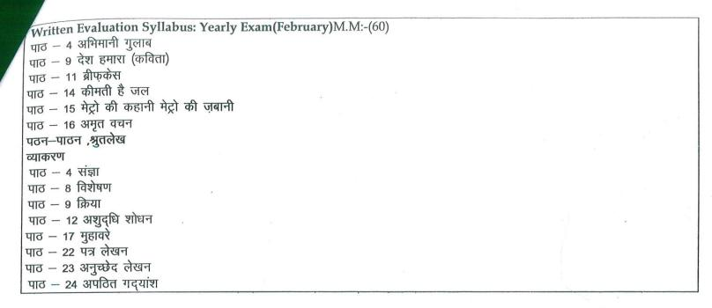
SUBJECT-MATH

MONTH | NO. OF WORKING DAYS | TOPIC | CONCEPT | ACTIVITY | WRORKSHEET
Apr. | 18 | L-3 Number system  L-4 Addition & subtraction | Place value & Face value of numbers | Place value chart on A-4 Sheet. | Worksheet of L-3+ Tables (2 to 8)
May | 8 | L-4 Addition & subtraction (Cont.) | Calculation & numeracy skills |  | Worksheet of L-4
Jul. | 24 | L- 5 Multiplication/ Division | Calculation & numeracy skills | Shortcut methods for calculation(Multiplication of any number by 5 ). | Recapitulation of PA chapters+ Tables 2 to 12
Written Evaluation Syllabus: PA-I(July) MM(40)
L-3 Number System
L-4 Addition and Subtraction
L-5 Multiplication
Aug. | 25 | L- Division  L-6 Factors & multiples  L-9 Fractions  L- 10 Decimals | - Learning about numbers less than whole.  - Learning about Factors and multiples | - Making a fraction disc. | Worksheet of L-9,10,14 + Tables 13 to 15
Sep. | 4 | L- 10 Decimals (cont) |  | - Find the price of 10 grocery items and write their number names | Recapitulation of Half yearly chapters + Tables 2 to 15
Written Evaluation Syllabus: Half yearly Exam(September) MM(60)
L- 4 Addition and Subtraction
L- 5 Multiplication/ Division
L-6 Factors & multiples
L-9 Fractions
L-10 Decimals
Oct. | 17 | L-11 Money  L-12 Measurement | Units of measurement and conversions | Measure the length of five objects in the classroom and do the conversions | Worksheet of L-11,12 + Tables 16 to 18
Nov. | 9 | L-13 Unitary method  L- 14 Geometry | Calculation of perimeter of regular and irregular figures | Find the length and breadth of any five things in the classroom and find their perimeter. | Recapitulation of PA chapters
Written Evaluation Syllabus: PA-II(November) MM(40)
L-11 Money
L-12 Measurement
L-13 Unitary method
L- 14 Geometry
Dec. | 20 | L-15 Perimeter  L-18 Time  L-19 Calendar | - Duration of time  - Learning about a.m. and p.m. | - To make a model of a clock  - Calculation of days using the school term calendar for a year. | Worksheet of L-18,19+ tables 18 to 20
Jan. | 19 | L-17 Symmetry  L-16 Three dimensional shapes  L-20 Pictograph | Learning about symmetry in nature  To observe and understand 3-D objects | - Cut and paste five symmetrical figures on A3 sheet. | Recapitulation of yearly chapters+ Tables 2 to 20
Written Evaluation Syllabus: Final Exam(February)MM(60)
L-13 Unitary method
L- 14 Geometry
L-15 Perimeter
L-17 Symmetry
L-18 Time
L-19 Calendar
L-20 Pictograph

SUBJECT-SCIENCE
MONTH | NO OF WORKING DAYS | TOPIC | CONCEPT | ACTIVITY | WOKSHEET
April | 18 | L-6 , The Green Plants  L-7, How plants survive?  L-3, Clothes we wear | 1. Showing a real plant and different leaves.  2. To enable the students to write their own answers with the help of creative writing.  1. Showing pictures of different types of plants. e.g-mountain plants, desert plants etc.  1. Showing different types of clothes worn in different seasons | Collect 5 leaves of different shapes and sizes and write the names of the trees they belong to and paste on A4 sheet.  Draw a plant and show the things we get from it by pasting around it.  (Do it on A4 Sheet)  Paste pieces of clothes made from different materials and also write the type of its fibre. | Worksheet based on L-6 and 7
May | 8 | L-9,Animals and their young ones | 1. Showing parts of an egg.  2. Pictures of life cycle of a hen, frog and butterfly | Draw the life cycle of following animals according to your R.No on A4 Sheet.  1to12-Life cycle of a frog.  13to24-Life cycle of a butterfly.  25 to35-Life cycle of a hen. | Worksheet based on L-3 and 9
July | 24 | L-10 How animals survive?  L-1,Food our basic need | 1. Showing pictures of different types of animals.  1. Showing flash cards/chart of different nutrients. | Make a poster on an endangered animal and write catchy lines on it.  Make a list of food items that you had in the last 3 days in breakfast ,lunch, dinner and check whether you have taken balanced meal or not. | Recapitulation worksheet for  PA-1
Written Evaluation Syllabus: PA –I(July) MM(40)

L-3, Clothes we wear
L-6 , The Green Plants
L-7, How plants survive?
L-9,Animals and their young ones
L-10 How animals survive?(only define and book exercise)
Aug. | 25 | L-2, Digestion and role of microbes  L-8, Circulatory and excretory system | 1. Showing the pictures of different types of teeth and digestive system.  2. Showing a picture of structure of a tooth.  1. Visiting the lab to show the charts of these systems. | Write any 5 healthy eating habits on A4 sheet. Also paste  Related pictures to make it attractive.  Draw and colour the excretory system in the notebook. |  | Recapitulation worksheet for Half Yearly Exam
Sep. | 4 | Revision for Half Yearly Exams
Written Evaluation Syllabus: Half Yearly Exam(September) MM(60)
L-1,Food our basic need
L-2, Digestion and role of microbes
L-3, Clothes we wear
L-6 , The Green Plants
L-7, How plants survive?
L-8, Circulatory and excretory system
L-9,Animals and their young ones
L-10 How animals survive?
Oct. | 17 | L-4, Solid ,liquids and gases  L-5, Soil | 1. Experiment showing solute, solvent & solution.  2. Visiting lab to show separation of mud and water using sedimentation and decantation.  1. Showing different types of soil.  2. Showing different layers of soil. | Collect salt, sugar, tea leaves, flour and tell whether these are solids or liquids. Also observe if these are soluble or not. Do on page 50 in the book.  Draw &colour different layers of soil in the notebook. |  | Worksheet based on L-4,5
Nov. | 9 | L-12,Air,water and weather | 1. Picture of water cycle.  2. Activity to show that water vapours are present in the air. | Draw water cycle in the notebook. |  | Recapitulation worksheet for PA-2
Written Evaluation Syllabus: PA II(November) MM(40)
L-1,Food our basic need
L-4, Solid ,liquids and gases
L-5, Soil
L-8, Circulatory and excretory system
L -12,Air,water and weather
Dec. | 20 | L-11, Force, Work & Energy  L-14,Keeping our earth green | 1. Using real objects to show the concept of friction and gravity.  1.To tell them the importance of clean and green environment | 1. Paste the pictures of different types of simple machines used in daily life.  2. Making an attractive paper bag using an old news paper. |  | Worksheet based on L-11and 14
Jan. | 19 | L-13, The Solar System | 1. Experiment to show the concept of formation of Day and night. | Draw and colour the solar system on A4 sheet
Feb. | 6 | Revision for final exam |  |  |  | Recapitulation worksheet for final exam
Written Evaluation Syllabus: Yearly Exam(February) MM(60)
L-2, Digestion and role of microbes
L-4, Solid ,liquids and gases
L-5, Soil L-11, Force, Work & Energy
L-6 , The Green Plants
L-11, Force, Work & Energy
L-12,Air,water and weather
L-13, The Solar System
L-14,Keeping our earth green

SUBJECT-SOCIAL STUDIES
MONTH | NO. OF WORKING DAYS | TOPIC | CONTENT | ACTIVITY | WORKSHEET
April | 18 | L-1. The face of India  L-2. Northern Mountains | L-1.Understanding the Neighboring countries and physical divisions of India  L-2. Discussion on Life in the northern mountains. | L-1. Mark states on the map.  L-2. Map Work | Given at the back of the Chapter
May | 8 | L-3. The Northern Plains | L-3. Showing flash cards of various River basins. | L-3. Map Work | Given at the back of the Chapter
July | 24 | L-4. The great Indian desert  L-5.The Southern Plateaus  L-6. The Coastal Plains and the islands  L-7. Climate of India | L-4. Discussion on life in the Desserts.  L-5. Discussion on Life in the Southern Plateau.  L-6.Life in the western coastal plains and eastern coastal plains  L-7. Showing Flash cards on Factors influencing the climate. | L-4. Collect pictures of the Thar desert and make a collage.  L-5. Map Work  L-6.Map Work  L-7. Make Collage on different seasons of India,  Map Work. | Given at the back of the Chapter
Written Evaluation Syllabus: PA-I(July) MM:-40
L-1. The face of India L-2. Northern Mountains
L-3. The Northern Plains L-4. The great Indian desert
Aug. | 25 | L-8. Soils of India  L-9. Forests and Wildlife  L-10. Our Water Resources | L-8. Showing Formation of Soil through pictures.  L-9.Understanding Our Wildlife and its importance.  L-10. Understanding the importance of water in our life. | L-8.Map Work  L-9.Map Work  L-10.Draw different resources of water. | Given at the back of the Chapter
Sept. | 4 | Revision |  |  | Worksheet based on above chapters.
Written Evaluation Syllabus: Half Yearly Exam(September) MM:-:60
L-1. The face of India L-2. Northern Mountains L-3. The Northern Plains
L-4. The great Indian desert L-5.The Southern Plateaus L-6. The Coastal Plains and the islands
L-7. Climate of India L-8. Soils of India L-9. Forests and Wildlife
L-10. Our Water Resources

Oct. | 17 | L-11. Our Mineral Resources  L-12.Our Human Resources  L-13. Our Agriculture and Livestock | L-11. Knowing the difference between Metallic and Non Metallic minerals.  L-12. Human Resources.  L-13. Knowing various Food Crops and Cash Crops in India. | L-11.Map Work  L-12.Collect 1 news clipping each from daily newspaper describing the problems of illiteracy, unemployment and poverty in India.  L-13. Draw 2 food crops and 2 cash crops | Given at the back of the Chapter
Nov. | 9 | L-14. Our Industries  L-15.Means Of transport  L-16. Means of Communication | L-14. Discussion on Large and small scale Industries in India  L-15.Means of transport-Land, water and air transport  L-16. Personal ,Mass and Satellite communication | L-14.Find out the names of 2 cottage, 2 small and 2 large scale industries in India.  L-15.Word grid  L-16. Draw one device each for personal, mass and satellite communication | Given at the back of the Chapter
Written Evaluation Syllabus: PA-II(November)MM:- 40
L-11. Our Mineral Resources L-12.Our Human Resources
L-13. Our Agriculture and Livestock L-14. Our Industries
L-15.Means Of transport
Dec. | 20 | L-17. Our Government  L-18.Our Goals, Rights and duties  L-19.Our National Symbols | L-17. Understanding the importance of government.  L-18.Our goals, fundamental rights , duties and directive principles  L-19. Showing flash cards on various National symbols. | L-17.Draw the hierarchy of judicial system of India  L-18.Collect pictures of leaders who have framed the constitution.  L-19. Draw the national symbols | Given at the back of the Chapter
Jan. | 19 | L-20.Our Art and Culture  L-21. They made history | L-20.Our Languages , dresses , dances , paintings and festivals  L-21. Knowing various Social Reformers, mathematicians, astronomers, kings, physicians. | L-20.Collet pictures of famous monuments and make a collage  L-21Make a. Collage showing the social reformers, astronomers and great kings of ancient India | Given at the back of the Chapter
Written Evaluation Syllabus: Yearly Exam (February) MM:-60
L-11. Our Mineral Resources L-12.Our Human Resources L-13. Our Agriculture and Livestock
L-14. Our Industries L-15.Means Of transport L-16. Means of Communication
L-17. Our Government L-18.Our Goals, Rights and duties L-19.Our National Symbols
L-20.Our Art and Culture L-21. They made history

SUBJECT-COMPUTER
MONTH | NO. OF WORKING DAYS | CONTENT | ACTIVITY |  | PRACTICAL | WORKSHEET
April | 18 | Ch – 1 : Knowing Computer system  Ch – 4 : Knowing Ms-Word 2016( Reading) | * Draw IPO cycle in notebook.  * Paste different input devices and output devices in notebook. |  | * Ms- Word | Ch-1
May | 8 | Ch – 4 : Knowing Ms-Word 2016 ( Exercise) | *Draw Word 2016 screen and write Keyboard Shortcuts commands in the notebook. |  |  | Ch-4
July | 24 | Revision  Ch – 5 : More on Ms-Word 2016(Reading) | *Draw font control tools and Write Formatting Shortcut Keys commands of Ms-Word in notebook. |  | *Ms - Word | Ch - 5
Written Evaluation Syllabus: PA-I(July) MM:-20
Ch – 1 : Knowing Computer system
Ch – 4 : Knowing Ms-Word 2016( Reading)
Practical : MS- Word
Aug. | 25 | Ch – 5 : More on Ms-Word 2016(Exercise)  Ch – 2 : More on Windows  Ch – 6 : Introduction to Powerpoint 2016 | * Draw different features of Windows 10 in notebook.  * Draw Ms- Power Point 2016 Window in notebook. |  | * Ms- Powerpoint | Ch-2,6
Sep. | 4 | Revision
Written Evaluation Syllabus: Half Yearly Exam(September) MM:-:30
Ch – 2 : More on Windows
Ch – 5 : More on Ms-Word 2016
Ch – 6 : Introduction to Powerpoint 2016
Practical : MS- Word
Oct. | 17 | Ch –7 Working with Powerpoint 2016 |  | * Draw different buttons / icons of powerpoint in notebook. | *Ms-  Powerpoint | Ch-7,3
Nov. | 9 | Ch – 3 : Files and Folders |  | * Draw different types of file icons in notebook.
Written Evaluation Syllabus: PA-II(November)MM:- 20
Ch –7 Working with Powerpoint 2016
Ch – 3 : Files and Folders
Practical : Power Point
Dec. | 20 | Ch – 8 : Logical Thinking  Ch – 9 : More on scratch |  | * Draw scratch mascot and different tools of scratch window in notebook. | * MS Power  point | Ch-8,9  Ch-10
Jan. | 19 | Ch – 10: Knowing Internet |  | *Draw web browser tool bar in notebook.
Feb. | 6 | Revision
Written Evaluation Syllabus: Yearly Exam(February)MM:-30
Ch – 8 : Logical Thinking
Ch – 9 : More on scratch
Ch – 10: Knowing Internet
Practical : Power Point

SUBJECT- G.K.

MONTH | NO. OF WORKING DAYS | CONTENT
April | 18 | Page no. 3 to Page no. 10 and Page no. 69
May | 8 | Page no. 11 to Page no. 15
July | 24 | Page no. 16 to Page no. 20 and Page no. 67  Revision
Written Evaluation Syllabus: PA-1(July) M.M.-20
Page no. 3 to Page no. 15 and Page no 69
Aug. | 25 | Page no. 21 to Page no. 32 and Page no. 68  Current Affairs
Sept. | 4 | Revision
Written Evaluation Syllabus: Half Yearly Exam (September) M.M.-30
Page no. 16 to Page no. 32,
Page no 67 and Page no. 68
Current Affairs
Oct. | 17 | Page no. 33 to Page no. 44
Nov. | 9 | Page no. 70  Revision
Written Evaluation Syllabus: PA-II(November) M.M.-20
Page no. 33 to Page no. 44and Page no. 70
Dec. | 20 | Page no. 45 to Page no. 60
Jan. | 19 | Page no. 61 to Page no. 66, Page no. 71 and 72  Current Affairs, Revision
Feb. | 6 | Revision
Written Evaluation Syllabus: Yearly Exam (February) M.M.-30
Page no. 45 to Page no. 66,
Page no. 71 and 72
Current Affairs

SUBJECT-DRAWING & ART/CRAFT
MONTH | NO. OF WORKING DAYS | PAGES OF ART BOOK | ACTIVITY
April | 18 | 3,4,16,17,32 | Spring Tree (Toothbrush splatter) 16  Landscape (sandpaper Activity) 32
May | 8 | 5,9,18,33 | Dinosaurs (Finger print impression) 18  Hot – grass posting
Summer Break :
July | 24 | 6,7,20,21,22,34 | Breezy day – cotton impression  In the sea – stencil design 21  Spider man – wool pasting 34
Aug. | 25 | 10,23,24,35,36 | Landscape – sponge impression 23  Dragonfly – leanes pasting  Butterfly – paper quilling
Sep. | 4 | Revision
Written Evaluation Syllabus: Half-Yearly Exam(September)
Page no.: 3-7, 9 and page no.10
Page no: 16 to24
Page no.: 32 to 36
Oct. | 17 | 11,25,26,37 | Sun – madhubani art  Paper tree 37
Nov. | 9 | 12,13,27,28,38 | Sheep – spongue and finger 28  Book jacket decoration 38
Dec. | 20 | 8,14,29,30,39,40 | Bubble art 39  Village – paper collage
Jan. | 19 | 15,31,41 | Coconut tree- crape paper tearing and pasting
Feb. | 6 | Revision
Written Evaluation Syllabus: Yearly Exam(February)
Page no. 8 and page no. 11 to 15
Page no. 25 to 31
Page no. 37-41

SUBJECT-DANCE
Month | Number of Working Days | Topic
April | 18 | Foot, Shoulders, Hands, Neck, Waist movements
May | 8 | Foot, Shoulders, Hands, Neck, Waist movements
July | 24 | Aerobics and body stretching exercises  Body balancing movements
Aug. | 25 | Aerobics and body stretching exercises  Body balancing movements (Janmastmi Celebration)
Sep. | 4 | Free style dancing (Dussehra celebration)
Oct. | 17 | Free style dancing (Dussehra celebration)
Nov. | 9 | Western Dance (Christmas Celebration)
Dec. | 20 | Western Dance (Christmas Celebration)
Jan. | 19 | Patriotic dance (Republic day celebration)
Feb. | 6 | Patriotic dance (Republic day celebration)
- Presentation of houses activity

